华为AC6605与蓝海卓越Portal系统的对接

蓝海卓越统一无线认证平台支持华为Portal协议，能够跟市面上支持华为协议的设备进行对接，方便的实现Web Portal认证。下面我们介绍华为主流6605系列AC同蓝海卓越统一无线认证平台的对接示例，仅供大家参考。

网络拓扑如下：
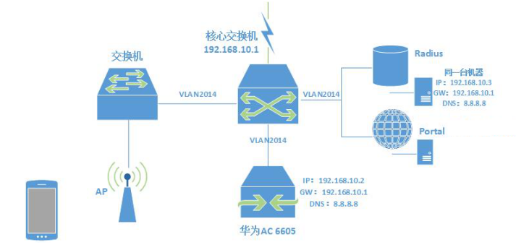
华为AC6605与蓝海卓越Portal系统的对接

配置说明：

1、将无线认证用户及设备划分到VLAN2014

#

vlan 2014

description user_vlan

#

2、配置Radius认证模板

#

radius-server template radius_huawei

radius-server shared-key cipher %@%@,%+K=Sl9NOmxy2@J~"X//97v%@%@

radius-server authentication 192.168.10.3 1812 weight 80

radius-server accounting 192.168.10.3 1813 weight 80

undo radius-server user-name domain-included

#

#

url-template name urlTemplate_0

#

3、配置Portal认证对接的参数

#

web-auth-server portal

server-ip 192.168.10.3

port 50100

shared-key cipher %@%@qfU0XjxGk-{_|i"4x;<,/v~S%@%@

url http://192.168.10.3:8080/login.jsp

url-template urlTemplate_0

user-sync

#

4、配置无线认证用户的地址池、网关及DNS

#

ip pool wifi_user

gateway-list 192.168.10.1

network 192.168.10.0 mask 255.255.255.0

excluded-ip-address 192.168.10.1 192.168.10.40

lease day 0 hour 1 minute 0

dns-list 8.8.8.8

#

5、配置AAA模板

#

aaa

authentication-scheme default

authentication-scheme radius_huawei

authentication-mode radius

authorization-scheme default

accounting-scheme default

accounting-scheme radius_huawei

accounting-mode radius

domain default

domain default_admin

domain huawei.com

authentication-scheme radius_huawei

accounting-scheme radius_huawei

radius-server radius_huawei

local-user admin password cipher %@%@lA9^Vm7sN452P)V;[5<Fcc>(%@%@

local-user admin privilege level 15

local-user admin service-type telnet ssh ftp web http

#

6、配置VLAN2014的地址以及在该Vlan中启用Portal认证

#

interface Vlanif2014

ip address 192.168.10.2 255.255.255.0

web-auth-server portal direct

dhcp select global

#

7、其他配置如下：

#

interface GigabitEthernet0/0/1

port link-type access

port default vlan 2014

#

interface GigabitEthernet0/0/2

port link-type access

port default vlan 2014

#

#

interface GigabitEthernet0/0/24

port link-type trunk

port trunk allow-pass vlan 2014 to 2015

#

interface XGigabitEthernet0/0/1

#

interface XGigabitEthernet0/0/2

#

interface Wlan-Ess0

port hybrid pvid vlan 2014

undo port hybrid vlan 1

port hybrid untagged vlan 2014

permit-domain name huawei.com

force-domain name huawei.com

#

interface Wlan-Ess1

description no_portal

port hybrid pvid vlan 2014

undo port hybrid vlan 1

port hybrid untagged vlan 2014

#

interface NULL0

#

ip route-static 0.0.0.0 0.0.0.0 192.168.10.1

#

以上即为蓝海卓越统一无线认证平台与华为AC6605对接的示例，仅供大家参考，如有问题可以随时在官网咨询。

另外，在部分场景，需要使用MAC无感知认证，请参阅华为配置手册。

